Physics: 14. Electricity in the home
Please remember to photocopy 4 pages onto one sheet by going A3→A4 and using back to back on the photocopier

Syllabus
OP53 Describe the heating effect, the chemical effect, and the magnetic effect of an electric current, and identify everyday applications of these, including the action of a fuse

OP54 Distinguish between direct and alternating current; recall that the voltage of the mains supply is 230 volts a.c.

OP55 Recall that the unit of electrical energy used by electricity supply companies is the kilowatt-hour, and calculate the cost of using common electrical appliances, based on their power rating

OP56 Describe how to wire a plug correctly, and explain the safety role of a fuse or circuit breaker in domestic electrical circuits.
Student Notes

Effects of an electric current

There are three effects of an electric current; a heating effect, a magnetic effect and a chemical effect

Effect | Demonstration | Everyday application
Heating Effect | An electric current will cause a light-bulb to heat up and emit light | Electric kettle, electric fire etc.
Magnetic Effect | An electric current will deflect a magnetic compass | Electromagnets
Chemical Effect | Electrolysis occurs when an electric current splits water into hydrogen and oxygen | Electroplating

Demonstrations
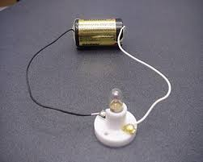
Heating Effect | Magnetic Effect | Chemical Effect

Alternating Current (a.c.) and Direct Current (d.c.)

Direct current is current which flows in one direction only; alternating current is current which constantly changes direction.

Mains Electricity

Electricity which comes through the sockets in your house is referred to as ‘mains’ electricity’.
It changes direction 50 times per second and so is called alternating current (a.c.).
‘Mains’ voltage is 230 volts

Look at the back of your electrical appliance and it will state this voltage and also the power.

Fuses

A fuse is a deliberate weak link in a circuit which will break (melt) if the current exceeds a preset value

The 3-pin plug
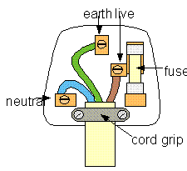

- The neutral wire is blue.
- The earth wire is yellow or green.
- The live wire is brown or red.
- The fuse is on the live wire.

Cost of electricity - the kilowatt-hour
The kilowatt-hour is the unit electrical energy used by electricity suppliers.
The photograph shows a kWh (kilowatt-hour) meter.
This meter is connected into the electricity consumer’s domestic circuit and it can measure energy consumption in a selected part of the circuit, the total energy used and cost it.
The meter can be wall-mounted in a convenient place.

The unit of electrical energy used by electricity supply companies is the kilowatt-hour

The number of kilowatt-hours equals the number of kilowatts multiplied by the number of hours

kWh = kW × hours

Example
The ESB charges for electricity at a rate of 11 cent per kW h.
A hair-drier of power rating 1.5 kW is used for 20 minutes each day.
(i) How many units of electricity are used in six days?
(ii) What is the cost, in cent, of using the hair- drier for six days?
Answer
  - Six days corresponds to 120 minutes or 2 hours.
The number of kWh = kW × hours = 1.5 × 2 = 3 kWh
  - Cost = 3 kWh × 11 cent per kWh = 33 cent

The power rating of various appliances
You don’t have to remember the numbers – just remember which machines use a lot of power and which use relatively little.
In general, if an appliance has a motor in it (something which moves) then it will have a high power rating.

Appliance | Power (in watts) | kilowatts (kW)
Washing machine | 2500 | 2.5
Microwave | 700 | .9
Light-bulb | 40 | .04
Lamp | 60 | .06
Hair-dryer | 3000 | 3
Kettle | 600 | .6
Television

Activity
Check appliances at home (e.g. hairdryers, lamps, heaters etc) to find the power rating and use this to fill in the table below.

Appliance | Power-rating (kW) | Average hrs used in a week | kWhr per week | Cost over 1 week @ 14 c per unit (kWhr)

Exam questions
- [2007][2012]
Give one application of the magnetic effect and one application of the chemical effect of electric current.
- [2011 OL]
The diagram shows an electric current passing through a coil of wire in a beaker of water.
- After 15 minutes, what effect would you expect the current passing through the coil to have on the water?
- Name a household appliance that uses this effect of an electric current.

- [2008][2012 OL]
Distinguish between alternating and direct current.

- [2008] What is the average voltage of domestic alternating current in Ireland?

- [2006][2012]Explain, clearly, the safety role of fuses in household electrical circuits.
- [2011 OL][2008] [2008 OL] [2007 OL] [2006 OL][2012 OL]
Wiring a plug correctly is most important.
- Give the names of the wires labelled A, B and C.
- Give the colours of the plastic insulations on the wires labelled A, B and C.
- Give one reason why the back covering (casing) of a plug is made from plastic.
- Which wire is the fuse is connected to?
- What is the function of the fuse in a plug?

The Kilowatt Hour
- [2012]
The kilowatt-hour is the unit electrical energy used by electricity suppliers.
The photograph shows a kWh (kilowatt-hour) meter.
This meter is connected into the electricity consumer’s domestic circuit and it can measure energy consumption in a selected part of the circuit, the total energy used and cost it.
The meter can be wall-mounted in a convenient place.

Give two advantages to the consumer of having this type of meter.

- [2008 0L]
- What is the unit of electric current?
- What is the unit of electricity used by the ESB for costing?

- [2006 OL]
Appliances vary in the amount of electricity they use depending on their power rating.
A tumble drier has a high power rating of 2.5 kW.
- Name another appliance found in the home that has a high power rating.
- Name an appliance found in the home that has a low power rating.

- [2010]
- Name the unit of electrical energy that companies supplying electricity use to bill their consumers.
- Calculate the cost of using of using the electric kettle, shown in the diagram, for ten hours if a unit of electricity costs 15 cent.

- [2011]
A 20 W (0.02 kW) CFL bulb is equivalent to 115 W (0.115 kW) incandescent bulb.
Electricity costs 15 cent per kWh.
Calculate the cost of using each of these bulbs for 100 hours.

- [2007 OL]
An electric cooker has four hot plates. The total power rating of the four hot plates is 7 kW.
All four are used for a total of 2 hours each day.
- How many units of electricity (kWh) are used in 1 week?
- If electricity costs 11 cent per unit how much does this cost?

- [2006 OL]
The ESB charges for electricity at a rate of 12 cent per kW h.
A tumble drier of power rating 2.5 kW is used for 2 hours each week for 4 weeks.
  - How many units of electricity are used?
  - What is the cost, in cent, of using the tumble drier?
Exam solutions
- Magnetic effect: electromagnets/ door bells/ central locking in cars/ electric motor/ speakers.
Chemical effect: electroplating/ galvanising/ charging a battery/ electrolysis/ refining of copper.

- The current would heat the water
- Kettle, immersion, toaster, hair dryer, etc.
- Alternating current changes direction, direct current moves in the same (fixed) direction
- 220-240 volts
- The fuse melts if the current is too high and this breaks the circuit.

- A: Neutral B: Earth C: Live
- A: Blue B: Green C: Brown
- To prevent shock (electrocution) / safety / insulates
- Live
- The fuse melts if the current is too high
- Review cost of electricity on a daily basis/ locate what part of the house costs most (least)/ budget (save money)

- C: Ampere
- E: Kilowatt hour

- Cooker / kettle / toaster / washing machine / dish washer etc
- Reading lamp / radio / television

- The kiloWatthour (kWh)
- 3 × 10 = 30 kWh. 30 kWh × 15 cent = 450 cent / €4.5
- LCFL 0.02×100×15 = 30 cent
Other bulb 0.115×100×15 = 172.5 cent = €1.725

- 7 × 2 × 7 = 98
- 98 × 11 = €10.78

  - 2.5 × 2 × 4 = 20 kWh
  - 20 × 12 = 240 cent
Electricity Crossword
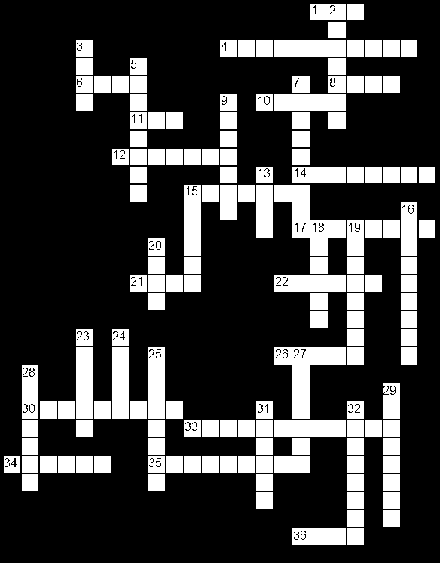

Across
1. The unit of resistance. (3)
4. This type of current constantly changes direction. (11)
6. The fuse is on this wire. (4)
8. Thin metal used to connect electrical components (4)
10. Colour of live wire in a plug. (5)
11. The unit of current. (3)
12. This must be complete in order for current to flow. (7)
14. Electrolysis is an example of this effect of an electric current. (8)
15. Movement of electric charge around a complete circuit. (7)
17. Electrical component used to reduce the flow of current in a circuit. (8)
21. Colour of neutral wire in a plug. (4)
22. An electric circuit with components placed one after the other. (6)
26. This type of voltage is 230 volts. (5)
30. Resistance opposes the movement of these around an electrical circuit. (9)
33. Unit of electrical energy used by electricity supply companies. (12)
34. Colour of earth wire in a circuit. (6)
35. A substance that does not allow charge to flow through it. (9)
36. A thin metal wire that is designed to melt when the electric current is too large. (4)
Down
2. The kettle and electric kettle are examples of this effect of an electric current. (7)
3. The unit of potential difference (or 'voltage'). (4)
5. The opposite of positive, usually has a black terminal. (8)
7. A substance that allows charge to flow through it easily. (9)
9. Two or more electric cells form one of these. (7)
13. Two or more of these in series form a battery. (4)
15. Electric current is the flow of ... (6)
16. Electrical device that measures potential difference (voltage). (9)
18. Light, sound, heat, kinetic, electrical and chemical are all forms of ... (6)
19. Arrangement of bulbs in a Christmas tree. (8)
20. An electrical component that transforms electrical energy into heat and light. (4)
23. This type of current flows in one direction only. (6)
24. The rate of transforming energy. (5)
25. The compass is an example of this effect of an electric current. (8)
27. Electrical device that measures electric current. (7)
28. Electrical component that transforms electrical energy into sound energy. (7)
29. An electric circuit with more than one complete loop. (8)
31. This is used to make or break a complete circuit. (6)
32. The opposite of negative, usually has a red terminal. (8)

Other Test Questions
- List three effects of an electric current.

- Draw a diagram of the apparatus used to demonstrate each of the three affects of an electric current.

- Name one everyday useful application of the heating effect of an electric current.

- Name one everyday useful application of the magnetic effect of an electric current.

- What are the three terminals in a plug called?

- What colour wire is attached to each terminal?

- What is the function of the earth wire?

- What is the function of a fuse in a circuit?

- Which wire is the fuse on, and why?
- What voltage is mains electricity?
- A hair-dryer uses 5 amps of electricity. Will it operate if its plug has a 3 A fuse? Give a reason for your answer.
- The expected current flowing through a certain circuit is 2.4 Amps. Which of the following fuses is most appropriate; 1A, 2 A, 3A, 5A or 13A?
The kilowatt-hour
- What is the unit of electrical energy used by the E.S.B. on electricity bills?
- What is the rule used to calculate the number of kilowatt-hours used by an appliance?
- Give a typical power rating (in watts) of any electrical appliance that you have at home. Name the appliance.
- Calculate the cost of running a 2.4kW electric fire for 5 hours if each unit of electricity costs 8 pence.
- A 600 Watt cooker is on for 30 minutes. If each unit of electricity costs 11 cent, calculate the cost of running the cooker.
Teaching Electricity in the Home
Syllabus
OP53 Describe the heating effect, the chemical effect, and the magnetic effect of an electric current, and identify everyday applications of these, including the action of a fuse

OP54 Distinguish between direct and alternating current; recall that the voltage of the mains supply is 230 volts a.c.

OP55 Recall that the unit of electrical energy used by electricity supply companies is the kilowatt-hour, and calculate the cost of using common electrical appliances, based on their power rating

OP56 Describe how to wire a plug correctly, and explain the safety role of a fuse or circuit breaker in domestic electrical circuits.

OP53: Describe the heating effect, the chemical effect, and the magnetic effect of an electric current, and identify everyday applications of these, including the action of a fuse

Three effects of an electric current
Affect | Demonstration
Heating Affect | Use a calorimeter (or light-bulb) and a thermometer
Magnetic Affect | An electric current will deflect a magnetic compass
Chemical Affect | Electrolysis occurs when an electric current splits water into hydrogen and oxygen

OP54: Distinguish between direct and alternating current; recall that the voltage of the mains supply is 230 volts a.c.
A nice analogy for alternating current in a circuit is the bicycle chain. It forms a complete circuit and reinforces the notion that electrons just have to flow through a component; they don’t have to ‘go’ anywhere.
Show students that at the back of every electrical appliance (which takes ‘mains’ electricity) is a label which illustrates.
It should also show the frequency as being between 50 and 60 Hertz.
It should also show the power rating, which we come to next.

OP55: Recall that the unit of electrical energy used by electricity supply companies is the kilowatt-hour, and calculate the cost of using common electrical appliances, based on their power rating
- Make sure that students check the power-rating of appliances at home and then fill out the table in the notes.
- Bring in a bill from home, photocopy it and see if students can follow it.

OP56: Describe how to wire a plug correctly, and explain the safety role of a fuse or circuit breaker in domestic electrical circuits.

- Describe how to wire a plug correctly
This can get very messy so keep your own set of plugs and cheap screwdrivers.
I demonstrate it and whether or not students do it depends on the class.

- Explain the safety role of a fuse or circuit breaker in domestic electrical circuits
A nice way of demonstrating that a fuse is a deliberate weak link in a circuit is to use steel wool. It’s very impressive to see it burning if the classroom is dark and each group is doing the activity.

